M E D I A A L E R T

Announcing…the Debut of the Accessible Art Fair New York
Brussels' Acclaimed Artist-Led Art Fair
Presented by U.S. Partner MvVO ART

November 1-25, 2016 at the National Arts Club

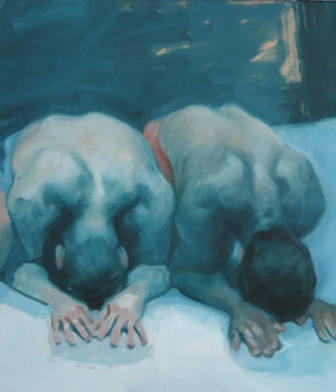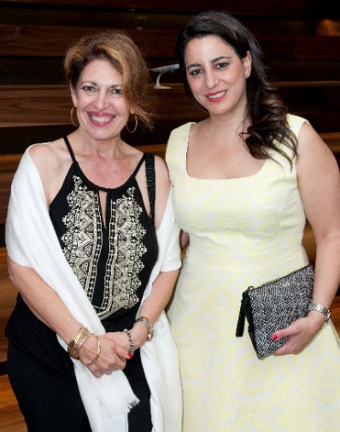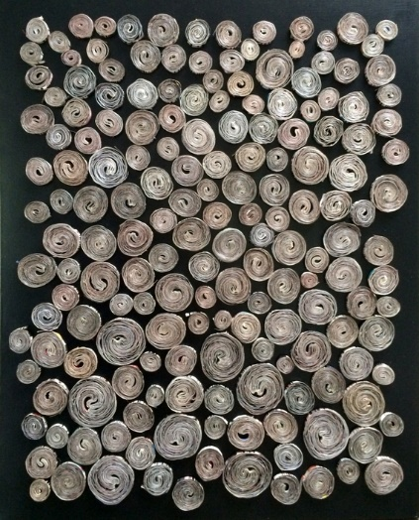

In Collaboration with Media Partner Artnet

TICKETS AVAILABLE NOW ONLINE

MvVO ART is proud to present the inaugural debut of the Accessible Art Fair New York, following ten successful years in Brussels. An expert jury has selected 60 rising-star artists, painters, sculptors and photographers from the rich and varied talent pool of New York and around the world. The work of these artists on the cusp of discovery will be displayed in one of New York City’s most enchanting venues — The National Arts Club — throughout November 2016. Tickets available at Eventbrite or at www.accessibleartfairnewyork.com. This year part of our ticket proceeds will be donated to Friends of Materials for the Arts.

“The Accessible Art Fair New York is a departure from conventional art fairs. The objective is to bring talented emerging and mid-career artists — unknown and often unrepresented — in direct contact with art collectors, art world professionals, and the general public. It’s an opportunity for everyone to discover new talent and break down barriers between artists and collectors, all within a high-end and friendly environment”.
—Maria van Vlodrop, Founder, MvVO ART and Director & Co-Founder, Accessible Art Fair New York

A Panel of Experts
To ensure the quality of the work presented, our panel of experts made selections from over 400 artist applications, which the Accessible Art Fair New York received during our Call To Artists in March & April 2016.

For the 2016 edition of the Fair, the panel welcomed: Kevin Doyle (Sotheby’s ) Shaune Arp (Gagosian Gallery), Rozalia Jovanovic (artnet), Ann Lydecker (Christie’s Collectrium), Rachel Rees (Sutton), Shari Brownfield (Art Advisor), Joyce Varvatos (Art Advisor), Sophie Clauvaert (ArtExpert) and Stephanie Manasseh (Brussels’ Accessible Art Fair Founder)

Curating the 2016 Fair in New York will be Stephanie Manasseh (Founder & Chief Curator, Accessible Art Fair), along with Guest Curator, Isaac Aden (Ethan Cohen, WhiteBox).

“We had such a wonderful response to our call for artists and I think our jury did a great job and made a fantastic selection of artists which we are planning to show. I am very excited to be working with my guest curator Isaac Aden. Isaac has extensive experience in New York. With our combined experience, I think we make a great team”.
—Stephanie Manasseh, Founder, Brussels’ Accessible Art Fair

The Accessible Art Fair New York will welcome a range of visitors including collectors, art enthusiasts, art advisors, gallerists and the art-buying public. Guests will have the chance to attend scheduled panels on a variety of art-world topics, such as: Practical Perspectives on Buying Art, Emerging Trends, and Contemporary Art Market Predictions.

WHEN: | November 1-25, 2016*
 | VIP First Access Night | 1 November | 6:00pm – 9:00pm
 | VIP Premier Event | 2 November | 6:00pm – 9:00pm
 | General Admission | 2-25 November | 10:00am – 5:00pm weekdays
 |  |  | 11:00am – 5:00pm weekends
WHERE: | The National Arts Club
 | 15 Gramercy Park South
 | New York, NY 10003
TICKETS: | Eventbrite  www.accessibleartfairnewyork.com
* The Fair will be closed November 8th, 2016 for Election Day and November 24th, 2016 for Thanksgiving.
* The Fair will be partially closed November 9th, 2016 from 12:00pm-3:30pm.

2016 Sponsors
Stoli Elit Ultra Luxury Vodka
Our VIP First Access evening on November 1st and VIP Premier Event on November 2nd will be sponsored by Stoli Elit, which consistently ranks amongst the finest white spirits in the world, ‘elit’ by Stolichnaya delivers smooth, rich and harmonious flavours to give you the ultimate vodka experience.

Brussels Airlines
Just as Brussels Airlines honors historic Belgian artists, the airline dedicates itself to promoting current and emerging Belgian artists. To do so, Brussels Airlines has teamed up with the Accessible Art Fair New York, presented by MvVO ART, to sponsor the Brussels Airlines ‘LIKES ART’ Award. The Brussels Airlines ‘LIKES ART’ Award will be presented to a favorite artist selected from among the 60 featured at the Fair. The public can vote via Facebook or while visiting the exhibit at the National Arts Club.

Neuhaus Belgian Chocolates
Neuhaus has been creating delicious chocolates since 1857. Inspired by a long-standing tradition, Neuhaus is the market leader in the luxury chocolate sector in Belgium. Accessible Art Fair New York visitors will have the chance to win an indulgent Neuhaus Chocolate prize.

2016 Primary Media Partner: artnet
Artnet is the leading online resource for the international art market, and the destination to buy, sell, and research art online. Founded in 1989 with the goal of bringing transparency to the art world, artnet’s comprehensive suite of products offers a variety of art market resources to our audience of collectors, dealers, and art enthusiasts

Partners
· Artnet - PRIMARY MEDIA PARTNER
· Tumblr - SOCIAL MEDIA PARTNER
· One Art Nation - CONTENT PARTNER
· The Clarion List - PREMIER ART DIRECTORY
· BelCham- BELGIAN - AMERICAN CHAMBER OF COMMERCE
· Christie’s Collectrium - ART COLLECTION MANAGEMENT
· The Lowell Hotel - LANDMARK LUXURY HOTEL
· Lawlor Media Group - PUBLIC RELATIONS PARTNER

Charity
We are delighted to recognize Materials for the Arts (MFTA): New York’s premiere creative reuse center, providing a way for companies and individuals to donate unneeded supplies to thousands of NYC public schools and nonprofit organizations with arts programming. MFTA is part of the New York Department of Cultural Affairs. This year part of our ticket proceeds will be donated to Friends of Materials for the Arts.

About MvVO ART:
MVVO ART is in the business of creating opportunities for artists, collectors, and corporate sponsors to discover each other and create powerful partnerships. At its debut in November 2016, MvVO ART will bring the Accessible Art Fair from its home in Brussels to the heart of the New York Art scene: The National Arts Club at Gramercy Park in Manhattan for a month long exhibition (November 1 to November 25, 2016). Maria van Vlodrop is the Founder and President of MvVO ART. In a new venture, Maria has partnered with Stephanie Manasseh, Founder & Director of Accessible Art Fair, to co-found and direct the Accessible Art Fair's New York edition, uncover new talent and encourage organizations to associate their brands with art to provide their customers with unique experiences.

For more information about MvVO ART & Accessible Art Fair New York
Main Website: http://www.mvvoart.com/
Event & Ticket Sales http://www.accessibleartfairnewyork.com

Social Media - Accessible Art Fair New York
Facebook: https://www.facebook.com/AccessibleArtFairNewYork/?fref=ts
Instagram: https://www.instagram.com/accafny
Twitter: https://twitter.com/accfny
Official Hashtag: #accafny

About the Accessible Art Fair Brussels:
Accessible Art Fair's mission is to offer a platform for artists & designers, and make them accessible to a discerning audience. Accessible Art Fair offers the opportunity to purchase quality works of art and meet the creators behind the work. All their works are carefully selected and hand-picked by a panel of experts and guaranteed the quality of the art presented. Accessible Art Fair is the place to discover great talent. The Accessible Art Fair also strives to make the art-purchasing experience as pleasant as possible, by removing the barriers between the buyer and the artist.

Founder Stephanie Manasseh started the organization in 2007 with the goal to create a platform for both talented emerging and established artists to sell their work to the art buying public.

For more information about the Accessible Art Fair Brussels, visit: http://www.accessibleartfair.com/brussels/

PRESS CONTACT
Norah Lawlor | Lawlor Media Group | www.lawlormediagroup.com
Norah@lawlormediagroup.com | Tel: (212) 967-6900
Facebook: LawlorMediaGroup | Instagram: lawlormedia | Twitter: @LawlorMedia

